Chapter 3.2 Second Half – Revenue, Cost, and Profit  Revenue refers to the amount of money received by a person or company. | 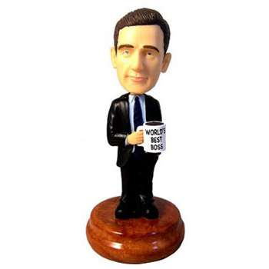

For instance, suppose that a company sold bobblehead dolls. Now, suppose that each doll sells for $20, and that the company sells 500 dolls. The company’s revenue works out to 500 x $20, which is $10000.

Cost refers to the money spent by that company in order to achieve their revenue.

Going back to our bobblehead doll example, it will cost the company money to produce all those dolls. They will also have to pay for advertising, as well as pay their salespeople, etc. For our example, let’s imagine the cost is $7000.

Profit refers to the amount by which revenue (the amount received by the company) exceeds cost (the amount spent by the company).

In our bobblehead doll example, we see that the company had to spend $7000 in order to make $10000. Therefore, Profit = Revenue – Cost. In this example, Profit = $10000 - $7000 = $3000.

In each new situation, we will have to determine a formula for Revenue, Cost, or Profit, depending on the facts of the case. We will have to use our wits to do this. Do you know what they say about common sense? The best way to assure yourself of being able to do these questions on a test is to do them for homework.

Example 2 from page 150: The cost, c(x), in dollars per hour of running a certain steamboat is modeled by the quadratic function $c(x)=1\text{.}8x^{2}−\text{14}\text{.}4x+\text{156}\text{.}5$, where x is the speed in kilometers per hour. At what speed should the boat travel to achieve the minimum cost?

The minimum or maximum value of a function is the y-value of the vertex.

Example 3 from page 151
The demand function for a new magazine is $p(x)=−6x+\text{40}$, where p(x) represents the selling price, in thousands of dollars, of the magazine and x is the number sold, in thousands. The cost function is $C(x)=4x+\text{48}$. Calculate the maximum profit and the number of magazines sold that will produce the maximum profit.

Another Example
A company owns a bus for taking students on ski trips. There are 22 seats on the bus. The costs to the bus company for each ski trip are as follows:
- a flat rate of $225
- an additional $30 for every student on the bus
The company charges $60 per seat if all of the seats are full, and it charges an additional $3 per ticket for every empty seat on the bus.
How many empty seats should there be to maximize the bus company’s profit?

Other Word Problems

Example 1 from page 148
A golfer attempts to hit a golf ball over a gorge from a platform above the ground. The function that models the height of the ball is $h(t)=−5t^{2}+\text{40}t+\text{100}$ where h(t) is the height in metres at time t seconds after contact. There are power lines 185 m above the ground. Will the golf ball hit the power lines?

Another Example
Show that the value of $m^{2}−6m+\text{11}$ cannot be less than 2.

Other Examples
1. A farmer has 300 metres of fence with which to build a rectangular area as shown. What dimensions will provide the greatest area possible?

- Jeremy has 500 metres of fence with which to build the area shown. What dimensions will provide the greatest area possible? (triangle on rectangle)

- An orchard owner grows apples. If she plants 30 trees per hectare, then each tree can yield 500 apples. For each additional tree she grows, every tree in that acre will yield 10 less apples. How many trees should she grow to establish the greatest yield of apples?
- Tania sells decorative pens at a convention. She knows that if the price of a pen is $20 per pen, she can sell 500 pens. For every additional dollar increase in price, she will sell 13 fewer pens. What price should she charge to maximize her revenue?

- Another orchard farmer, named Jojo, grows pears. If he plants 50 trees on an acre, he can grow 400 pears per tree (in other words, 200 pairs of pears – har har har). For every additional tree that he grows on an acre, he can grow 4 fewer pears on a tree.
  - How many extra trees should he plant to maximize his yield.

  - Each pear sells for 10 cents, and each tree costs 1 dollar to maintain. How many trees should he plant altogether to maximize his profit?

It’s uncommon.

