Angle of Elevation and Depression Date:_______________________________

The angle of elevation is the angle above horizontal that an observer must look to see an object that is higher than the observer. In the first picture below, the angle of elevation that a person must look up to see a hot air balloon is shown. In the second picture, the angle of elevation that a person must look up to see a treetop is shown.

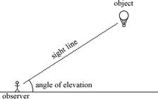 | 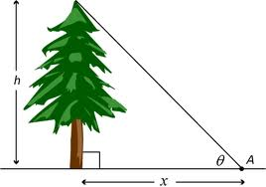

The angle of depression is the angle below horizontal that an observer must look to see an object that is lower than the observer. In the first picture below, the angle of depression that a person must look down from the top of a building to see a car is shown. In the second image, the angle of depression that a person in a hot air balloon must look down to see a bag of money is shown.

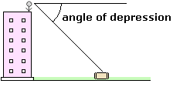 | 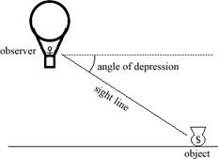

Imagine two people looking at each other. One person is on ground level, and the other is at the top of a building. The angle that the person on ground level has to look up is the same as the angle that the person on top of the building has to look down. It is a general rule that the angle of elevation is equal to the angle of depression in any situation.

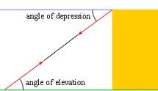 | 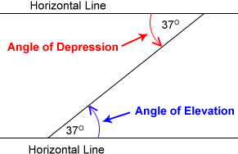

Rule of Thumb: The angle of elevation is equal to the angle of depression. They are both measured from the horizontal, not the vertical.
Angle of Elevation and Depression Word Problems

- Imagine an airplane with an altitude of 8500 m. Johnny looks up at an angle of elevation of 23º and sees the airplane. What is the horizontal distance from the airplane to Johnny? (include a diagram)

- An airplane is flying at an altitude of 7000 m, and it is currently 11500 m horizontally from Tiberius. If Tiberius looks up at it, what would the angle of elevation be?

- A submarine descends at an angle of depression of 6º and travels horizontally 1500 metres. What is the depth of the submarine?

- Eleanor is flying an airplane. She is a horizontal distance of 3 km from the airport, and she is flying at an altitude of 750 m. What should her angle of descent be?

- A wheelchair ramp is needed at the entrance of a restaurant. The ramp is to be 8.9 metres long and have a rise of 50 cm. What is the angle of inclination of the ramp?

- Safety standards mandate that the angle of inclination of a wheelchair ramp should be between 3º and 3.75º. Shelly built a ramp in front of her new shop with a horizontal length of 6 metres and a height of 36 cm. Is her ramp within standards?
More Angle of Elevation and Depression Word Problems Date:_____________________

- A wheelchair ramp is needed at the entrance of a restaurant. The ramp is to be 2.11 m long and have a rise of 0.18 m. Calculate the angle of inclination of the ramp.

- From the top of a bridge over the Welland Canal, Marcy looks down at a sailboat at an angle of depression of 17º. The bridge is 12 m above the water. Calculate the horizontal distance from the bridge to the sailboat.

- A 9.2 m flagpole is 2.6 m away from a pedestrian. What is the angle of elevation from where the pedestrian is standing to the top of the flagpole?

- Safety by-laws state that for a ladder to be stable, the angle the base of the ladder makes with the ground should be between 72º and 78º. A safety inspector at a construction site notices a painter on 12 m ladder that is leaning against a wall. The base of the ladder is 2.2 m away from the wall. Does the inspector have cause to be concerned?

- * - Two buildings are 25 m apart. The angle from the top of the shorter building to the top of the taller building is 15º. The angle from the top of the shorter building to the base of the taller building is 55º. What is the height of the taller building?

- * - Two buildings are 30 m apart. The angle from the top of the shorter building to the top of the taller building is 17º. The angle from the top of the shorter building to the base of the taller building is 42º. What is the height of the taller building?

